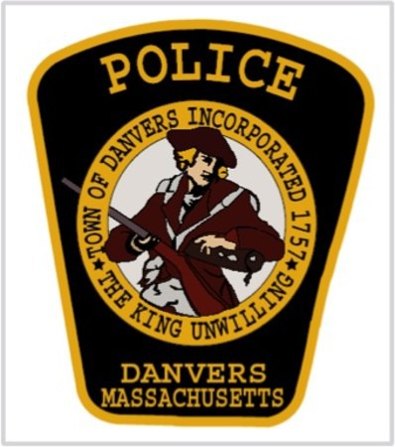

The Danvers Police Department is offering women a chance to learn self-defense skills. The classes will run from 5:30pm – 8:30pm at the Holten Richmond Middle School, Danvers, MA

Tuesday: May 15th and Thursday May 17th
Tuesday: May 22nd and Thursday May 24th
2018
Rape Aggression Defense System (R.A.D.) is a comprehensive women-only course that begins with awareness, prevention, risk reduction, and risk avoidance, and then progresses to cover the basics of hands-on defense training.

Classes are taught by Danvers Police Officers who are nationally certified R.A.D. Instructors. The class is limited to 25 and the participants must be at least 18 years of age. For more information please contact Sgt. Olivia Silva 978-774-1213 x4134 or at osilva@danversma.gov
Please fill out and mail, email, or fax your application:
Full Name : __________________________

Date of Birth : ________________________

Home Address : _______________________

City or Town : _________________________

Zip : _________________________________

Phone (Home) : ________________________

Phone (Cell) : __________________________
E-mail Address : ________________________

T-Shirt Size: ________
Fax 978-762-0258 or Mail to :

Sgt. Olivia Silva
Danvers Police Dept.
120 Ash Street
Danvers, MA 01923

